UNIT PLAN
Unit title: “We are living in a Material World” | Stage: 2 Year: 4
Term: 3 | Strand: Material World
Duration: 10 weeks, 10 ninety minute lessons | Sub-strand: Using material objects
RATIONALE
The Unit “We are living in a Material World” will allow students to develop their knowledge and skills in two specific scientific areas
- The change in solids and liquids when heating and cooling
- The properties of natural and processed materials and how this influences their use
The content in the NSW Syllabus for the Australian Curriculum Science K-10 (incorporating Science and Technology K-6) allows for the classroom teacher to plan a unit of work that incorporates both the constructivist learning approach while also using the 5E model. The unit of work “We are living in a Material World” allows students to use their prior knowledge and experiences to combine these with new scientific experiences to create or construct new knowledge. The unit “We are living in a Material World” has its foundations in the 5E model for both planning and implementing the activities in the unit. The 5E model has proved to be extremely effective as it ‘rests on a foundation of contemporary research on student learning, particularly in science’ (Bybee, Taylor, Gardner, Van-Scotter, Powell, Westbrook, Landes, 2006, p. 4) hence why it has become the foundation of the unit “We are living in a Material World.”

This unit will support the needs of various students including those students with special needs, gifted and talented students and Aboriginal and Torres Strait Islander students. Students with special needs and gifted and talented students will both be supported during this unit as the groups will be mixed ability, enabling students who are achieving beyond the outlined outcome to further their knowledge by instructing and sharing their knowledge with any special needs students. Aboriginal and Torres Strait Islander students will be supported during this unit of work as each lesson incorporates a link to the 8 ways of learning for Aboriginal and Torres Strait Islander students. (SNAICC, 2012, p. 45)

Throughout the unit students will receive a balance of theory-based experiences and ‘hands on’ experiences to ensure students of varying learning styles are able to understand the content being taught. At the start of the unit the students will be asked to draw upon their prior knowledge and experiences, this will enable the teacher to support the students when implementing the activities to ensure students are taking part in activities that build upon what they know and develop what they may not know.

The learning experiences planned in the unit require students to complete tasks using a variety of methods and skills, such as individual thinking and communication to group work involving students to bring together their individual ideas, to create a group product or achieve an outcome(s). The classroom/learning environment will be reflective of the activities that the students are required to take part in and complete. Throughout the learning environment technologies that will be required to complete the set activities such as iPads containing the required appropriate applications, digital cameras and interactive whiteboards.

During the unit, when students are completing the “Material World” outcomes they will also have the opportunities to develop their skills and knowledge in the areas of “Working Scientifically” and “Working Technologically.” When working scientifically students will use any prior knowledge and experiences they may have to pose answerable questions. Collecting and analysing data is a way in which students can achieve the “Working Scientifically” outcome. When students work technologically students use a range of appropriate tools and technologies in appropriate and safe ways to answer their answerable questions. Some examples of technologies students will use are thermometers, iPads, scissors, cameras and measurement implements.

The unit of work “We are Living in a Material World” allows students to experience inter-curricular links with two other Key Learning Areas, those being:
- English- Communicating in effective ways for various audiences and purposes & composing and editing a coherent text.
- Mathematics- Measuring and recording small distances, measuring and recording amounts, reading and recording time & selecting appropriate methods for data collection e.g. simple and appropriate graphs.

All of the specific learning engagement activities in the unit of work “We are living in a Material World” have been created following the 5 E model of teaching and learning. Each lesson follows a specific stage of the model, those stages being engage, explore, explain, elaborate and evaluate. As mentioned earlier Bybee et. Al, 2006 state that the 5 E instructional model of teaching and learning is very effective when educating students in areas such as science. The reason for the 5 E model being so effective is because students use their prior knowledge and experiences of science within their world to construct new knowledge in the classroom when they experience and explore scientific concepts in the classroom. In the unit of work “We are living in a Material World” the following phases of the 5 E model are demonstrated by:
- Engage- providing activities/experiences that captures students attention and curiosity, causing them to draw upon their prior knowledge and experiences of science in their everyday lives e.g. using technology and iPad applications to hold a class quiz and using hands on experiences where students are able to interact with specific objects. (Pre-assessment/formative assessment)
- Explore- providing experiences for students where they are able to explore free of unnecessary task constraints. This allows students to receive a common set of experiences regardless of their prior knowledge on a particular topic e.g. hands on experiences and the use of technology.
- Explain- allows students to focus on a particular area or question developed during the engage and explore phase. This is done in the unit of work by allowing students to design and create their own products e.g. drink cooler and model house in response to what has been learnt earlier on in the 5 E model. (Opportunity for formative assessment)
- Elaborate- enables students to receive constructive feedback from their teachers and also from their peers about their projects/investigations. Upon receiving this feedback students will then be able to make small changes and alterations to their designs/investigations.
- Evaluate- allowing students to evaluate themselves, their work, their peers work even the work of the teacher as students and teachers do not finish their learning journey once formal education is completed. Self-assessments will be completed to ensure students are focusing on their learning journey and ways it can be improved or changed. The students learning journey will also become an effective reflection tool as students are able to look back over their work to determine where they may be able to improve.
GOALS
KLA: Science Outcomes & Performance Indicators
ST2-12MW
-Identifies that adding or removing heat causes a change of state between solids and liquids
- Students predict and observe the effects of adding or removing heat in a variety of everyday solids and/or liquids
- Students describe hoe scientific knowledge about the effects of heating and cooling is used by people in their everyday lives
- Students record the time taken for a reaction to take place e.g. heating or cooling
- Students will collect and record data from their observations (heating and cooling solids and liquids)
ST2-12MW
-Identifies the physical properties of natural and processed materials, and how these properties influence their use
- Students will observe the changes that occur in the physical properties of everyday materials when they are heated, cooled, bent, stretched, folded and twisted
- Students will identify the properties of some natural and processed materials
- Students will describe how a range of common natural and man made materials are used in daily life
- Students will generate ideas about how the physical properties of some natural and man made materials influence their use
ST2-4WS
-Investigates their questions and predictions by analysing collected data, suggesting explanations for their findings and communicating and reflecting on the processes undertaken
- Students question and predict by using their prior knowledge, curiosity and predicting what might happen in an investigation when they draw upon their prior knowledge
- Students conduct investigations by following the safe planned method, safely using appropriate tools and by using appropriate recording methods
- Students communicate by representing and communicating their ideas in a variety of traditional and visual ways
ST2-5WT
-Applies a design process and uses a range of tools, equipment, materials and techniques to produce solutions that address specific design criteria
- Students generate ideas by using creative thinking, brainstorming, mind mapping etc and by using digital technologies where appropriate
- Students produce solutions by exploring a range of materials appropriate for the task, applying a plan and safely/correctly using tools and equipment
- Students evaluate by reflecting upon their processes and using criteria to evaluate the process
KLA: English Outcomes & Performance Indicators  EN3-1A  -Communicates effectively for a variety of audiences and purposes using increasingly challenging topics, ideas, issues and language forms and features  - Students describe language forms and features of spoken texts appropriate to a range of purposes, audiences and contexts  - Students use interaction skills e.g. paraphrasing, questioning, non-verbal cues and voice techniques  EN3-2A  -Composes, edits and presents well-structured and coherent texts  - Students re-read and edit for meaning by adding, deleting or moving words or word groups to improve content and structure  - Students re-read and edit texts for meaning, appropriate structure, grammatical choices and punctuation | KLA: Mathematics Outcomes & Performance Indicators  MA2-9MG  -Measures, records, compares and estimates lengths, distances and perimeters in meters, centimetres and millimeters and measures compares and records temperatures  - Students measure lengths and distances using meters and centimeters  - Students compare and order lengths and distances using meters and centimeters  MA2-11MG  -Measures, records, compares and estimates volumes and capacities using liters, milliliters and cubic centimeters  - Students recognise the need for formal units to measure volume and capacity  MA2-13MG  -Reads and records time in one-minute intervals and converts between hours, minutes and seconds  - Students use a stop watch for keeping time  MA2-12SP  -Selects appropriate methods for data collection and constructs, compares, interprets and evaluates data displays, including tables, picture graphs and column graphs  - Students pose questions about a matter of interest to obtain information that can be recorded in categories  Students collect data and create a list or table to organise the data e.g. collect data on the number of each colour of lollies in a jar
GOALS
Assessment – formative (during learning engagements)  - Students will take part in a pre-assessment in the engage phase to determine the students’ prior knowledge, experiences and abilities. This will be done in the form of a quiz using the “Nearpod” application on the iPads.  - Students will design and create a water bottle/drink cooler in activity five and 6, as students are designing, completing and presenting their project the teacher will be filling out a rubric based on the product made, their design techniques, their ability to reason and how suitable the materials were. There will be a formative assessment at this stage as students will complete another design and create project where they can be assessed again (summative) to show improvement in design skills and group work based off feedback they received when working on and presenting this activity.  - Rubric for the formative assessment see appendix 1 | Assessment – summative (at the end)  - Students will complete a formative assessment by designing and creating a model house. Students will be required to take into account in their design the specific condition the house will be in e.g. weather conditions.  - Students would have received feedback when completing their drink bottle cooler formative assessment and they must take into account any weaknesses or room for improvements to ensure they demonstrate this in the final summative assessment.  - Rubric for summative assessment see appendix 2  - Students will also create a video documenting their experiences and processes when designing and creating their model house. The students would have used the iPads to document by taking photos, videos and voice recordings. They must use this evidence and create a presentation. The presentation will be shown to the class and this will also be assessed.  - Rubric for summative assessment (presentation) see appendix 3
Work samples – to show understanding and achievement of outcomes

STUDENTS
Number: 21. 10 girls & 11 boys.
Differentiation needs  Tomlinson Model- The traditional approach to education where information is transferred into students has drastically changed in the last century. Teachers are now aware of the fact that there is a variety of different learning styles and methods that should be implemented in the classroom to best meet the needs of all students (Churchill et al, 2011, p. 226). ‘Differentiation is not the same as segmentation, which is a process whereby more of the same type of unit, rather than a new unit, is established’ (D. Adams and J. P. Farrell 1969 p24) Within this unit of work on Material World the Tomlinson Model will be implemented to best meet the needs of all students. Throughout the unit a variety of activities and student choice within activities will help meet the learning needs of most students. As within all activities there is aspects of speaking and listening through class or group discussion and presentations which best meets the needs of auditory learners. Consistently throughout the unit the students are provided with ‘hands-on’ activities such as making a model house and manipulating play-dough. These ‘hands-on’ experiences enable students that learn best through kinaesthetic experiences to be provided the best opportunity to experience new content in their preferred learning style. The third learning style within the Tomlinson Model is for visual learners, which will be catered for through watching and recording information about experiments and the different ways to manipulate materials.  Aboriginals Students:  When teaching Indigenous students it is important to ensure that their language and culture is respected and included throughout the unit (Hudson, 2013, p. 223). To ensure that the explicit needs of Indigenous students are met the Indigenous words of the local language group Wodi Wodi people of the Dharawal Nation will be used alongside the Australian- Standard English throughout the teaching of the unit.  To ensure that the specific needs of Indigenous students are met in week three when students are making play-dough the Indigenous Students will be provided with the opportunity to make clay. As this is a substance that has been used and passed down for millions of years within there culture.  The second activity that will be designed to specifically differentiate the specific needs of Indigenous students will be the Model House activity. In this task Indigenous students would be asked to use resources to make a traditional Indigenous shelter that the people of the Dharawal Nation would have inhabited before European settlement. Through adapting this activity for Indigenous students they are able to use the inextricable link to the land evident in Indigenous language groups to provide explanations in the next activity for why they have used their chosen materials.  Special Needs:  When adapting to meet the needs of students with special needs teachers need to ensure that, ‘What a student must know, understand and be able to do (the KUD’s) remains consistent for all students in the differentiated classroom (except in cases where Independent Learning Programs require different goals)’ (C. Thomlison 2014) Thus when differentiating for students with special needs learning activities will be adapted to cater for their needs but ensuring the learning goals are still the same. Throughout the unit students will be working in ability based groups at the end of the unit For example when creating the model house students with special needs will be given the city or suburban area to create their house in as these are easier than other environments. Whilst earlier in the unit students will be in mixed ability groups, this will allow students that may be struggling to seek help from their peers who have already grasped the concept.  Carol Tomlinson also argues that student’s products should be differentiated when creating a product. ‘Students can select from teacher-developed options, propose their own options, work in different modes of expression, use different media, or work in different configurations’ (C. Tomlinson, 2014). Thus when students create their presentations students with special needs will be given the choice to create a poster or dramatisation to present to the class instead of a video.  Gifted and Talented:  When meeting the needs of gifted and talented students teachers like when adapting lessons for students with special needs should guarantee that they do not change the learning goals for the lesson (C. Tomlinson, 2014). Students that are gifted and talented will be working together in the groups of three. Through putting gifted and talented students together it will provide them with the opportunity to work together and challenge each others opinions and views when creating the model house and predicting outcomes in experiments throughout the unit. When creating a house model gifted and talented students will be given a difficult environment to accommodate such as a snowy environment or rainforest to challenge them to be creative and innovative when designing their house model. In other activities gifted and talented students will be in mixed ability groups and be challenged to explain and help their peers who are struggling.  Grouping of Students:  Throughout the unit students will be working in a variety of different groups. In constantly changing the grouping of students the students are provided with the chance to be challenged in a variety of different ways. Students will also develop social skills through working with numerous members of their class throughout the unit. In changing the group the students learning is dynamic and interesting for them. It also avoids students from labelling groups as ‘bottom’ or ‘top’ thus decreasing circumstances that bullying can occur in. | Skills, interests and prior knowledge  - Lessons and the lesson sequence adequately maintain students attention and are engaged through students’ interests, prior knowledge and prior experiences.  - The students are given multiple opportunities to participate in ‘hands on’ activities and conduct experiments, which will gain student interest.  - Prior Knowledge  - Students have a strong knowledge of the science group roles – Manager, Director and Speaker – students are also know what each role entails.  - All students have an advanced understanding of the 5 class rules that were established at the beginning of the school year.  - Move into your team quickly and quietly  - Speak softly  - Stay with your team  - Take turns  - Perform your role  - Have an increasing knowledge and understanding of the Natural Environment and the Made Environment through the Material World  - ST2-12MW – identifies that adding or removing heat causes a change of state between solids and liquids  - ST2-13MW – identifies the physical properties of natural and processed materials, and how these properties influence their use.  - Students are able to identify ways that everyday materials can be physically changed and combined for a particular purpose.  - Are able to relate properties of common materials to their common use for particular purposes.  - Students are able to use their senses to identify the similarities and differences in the properties of materials  - Students are able to describe some everyday situations where solids and liquids change state with temperature.  - Students can predict and observe the effects of the changing temperature of common solids and/or liquids.  - Students are able to identify a range of materials used by Aboriginal and Torres Strait Islander people and share ideas about the ways they are sued to suit a particular purpose, e.g. the use of wood, stone and fibers in the built environment
LEARNING MATTER
ESSENTIAL UNDERSTANDINGS  STUDENTS WILL LEARN ABOUT…  - Heating and cooling solids and liquids  - Difference between heating and cooling  - Natural and man made materials  - Functions of natural and man-made materials  - Reasons for using particular materials  - Exploring their immediate surroundings  - Reading temperature | ESSENTIAL SKILLS  STUDENT WILL LEARN TO…  - Investigate, predict, observe, classify, explore, discover, experiment, document, plan, design and make and record findings, in relation to heating and cooling solids and liquids such as:  - Classify solids  - Classify liquids  - Heat and cool solids and liquids  - Plan and conduct an effective investigation  - Conduct themselves safely both inside and outside of the classroom  - Use technologies appropriately
RELATED TEXT-TYPES
- During the unit “We are living in a Material World” students will interact with various text types including
  - Procedure text- play-dough recipe
  - Report text - investigation planner/report
- EVALUATION:  - Did the individual lessons successfully engage the students?  - Were the instructions clearly explained?  - Were the outcomes and indicators reached in each lesson?  - Did each step go according to plan?  - Did the students actively involve themselves in class games and activities and workshops?  - Were the students challenged appropriately?  - Did the unit follow the 5E model?  - Did the activities require more time? Or were the activities given an appropriate time frame  - Did the students respond to the activities appropriately?  - Did the students assist each other?  - Were the students well behaved throughout each lesson?  - Did any of the students injure or hurt themselves? | - Did the students communicate well with my instructions during lessons?  - Did the students understand the concept of using the equipment and making experiments?  - Did the students work with their groups well?  - Did the students understand the given task without being explained repeatedly?  - Did the students react well to the lessons?  - Did the students give feedback of the lesson  - Did I learn anything from the students that I can apply to future units like this one?  - Was each students potential challenged throughout the activity?  - Was I able to help each individual student? Meeting their specific needs.  - Did the lessons flow across the unit?
LEARNING ENGAGEMENTS
5E Model | LEARNING ENGAGEMENTS | RESOURCES AND  PREPARATION | OUTCOME | SIGN-OFF
Engage | WEEK 1  - Children use iPads in groups of 2 or 3 to, as a group, answer interactive pre-test questions. Each group’s response is displayed on the Whiteboard using the nearpod application. Children communicate their thinking and conclusions.  - Children create a TWLH wall chart/ IWB chart using the ideas presented in the pre-test and any other additional ideas.  - What I THINK I know &  - What I WANT to know  - Students will use their prior knowledge to make some statements that begin with “I think I know…”  - Students then pose some questions for the teacher to record (this information will enable the teacher to fully plan a successful unit of work, some changes may need to be made to the following lesson once this information has been recorded on the chart)  - Children play an interactive game where they have to identify solids, liquids and gases, justifying their choices.  - Children observe 3 balloons and identify which balloon matches which state. Students will use their sense of touch, sight and knowledge of the states when manipulating each balloon in order to determine what matter is in each balloon. Once the students have made a decision in their groups the students will pop the balloons with the provided sharp objects.  - Students use their science journal to reflect upon any science processes, knowledge, skills and understandings that may have been developed during the science lesson. This can be done through writing or drawing diagrams.  Additional information  Literacy links- Students communicate in a spoken and written way and students also adopt a range of roles within their groups. Students can also identify the purpose of spoken text.  Numeracy links- N/A  Indigenous perspectives- 8 Ways community links as students will be working in small groups within their classroom community while also interacting with students outside their immediate group. Students are interacting with materials found in the natural environment (Aboriginal and Torres Strait Islander students may be close with the environment)  Risk Assessment- In this activity there are minimal risks. When students are using a sharp object to pop their balloon, they will use a safety pin to minimise chance of injury. | - iPads  - “Nearpod” application  - IWB  - TWLH Chart  - Markers  - Cardboard  - Solids and liquids online game  - Science journal | Science  ST2-12MW  ST2-13MW  ST2-4WS  ST2-5WT  English  EN3-1A  EN3-2A
Explore | WEEK 2  - Children are provided with a snap-lock bag each with a piece of ice. Students must attempt in various ways to melt the piece of ice using their own body. The teacher using a stopwatch will time this activity, the timer will be started when the students begin and will be stopped when the first student successfully melts their piece of ice.  - The teacher will ask the students question e.g.  - What method did you use?  - Why did you use it?  - Can you think of a method that may be more successful?  - What happened to the ice cube?  - What caused the change?  - Children then watch an animation describing the scientific process of melting an ice cube  - Teacher may like to ask students questions about the animation they watched.  - The first two parts of the TWLH chart will be added to  - Students then use their science journal to record/document their reflection, this may include written words or diagrams/drawings.  Additional Information  Literacy link- Students communicate in a spoken and written way and students also adopt a range of roles within their groups.  Numeracy link- Students are being timed during this activity with the winner completing the task in the shortest amount of time.  Indigenous perspectives- 8 Ways community link as students are required to work in their immediate science groups within their whole classroom community. Students have formed a close bond with their science groups and work well with these students.  Risk Assessment- Students will use stopwatches that have snap pull locks on them so that students are unable to strangle each other. There are minimal risks associated with this activity. | - Snap-lock bags  - Ice  - IWB  - Melting ice animation  - TLWH chart  - Markers  - Post-it notes  - Science journal | Science  ST2-12MW  ST2-13MW ST2-4WS  ST2-5WT  Mathematics  MA2-13MG  English  EN3-1A  EN3-2A
Explore | WEEK 3  - Read the students the book “Measuring Penny.” This children’s book talks about measuring various types objects in various ways. (Related to this activity when Penny measures ingredients for cooking)  - Explain to students the lesson they will be undertaking – making play-dough  - The teacher will establish students’ prior knowledge about play-dough through questioning by asking questions such as  - Have you played with play-dough before?  - Have you ever made play-dough?  - What do you think happens when we add wet and dry ingredients together?  - Show students all ingredients and name them to ensure students are aware of what they will be using.  - Ensure students are aware that they will be using the iPads to document each stage of the play-dough making by either taking photos, video/voice recordings or by drawing diagrams in their science journals.  - Ensure students are aware of the expectations for safety and cleanliness.  - Students will move into their science groups to complete the task.  - Students will then be provided with an incomplete recipe (appendix 4) that is missing the amounts required of the core ingredients to the play-dough. Students will be required to first interact with a pre-made piece of play-dough to determine what theirs must look and feel like before they attempt to create their own piece.  - In the case students are unsuccessful in creating their piece of play-dough they need to explain to the teacher why they think the play-dough did not turn out as it should have.  - Students need to then interact with the play-dough e.g. molding, stretching, ripping and bending the play-dough. They must then in their science journals take notes of how the play-dough can be manipulated and record what it feels like, smells like and looks like.  - During the final discussion students will discuss with the teacher and their peers what their recipe was by using their now completed recipe sheet.  - Students who struggled may like to share why their play-dough did not turn out like it should have.  Additional Information  Literacy link- Students will be communicating with their peers and teachers for a variety of purposes. Students will be exposed to a specific text type (process). They will also be able to complete the text type, as when they receive the recipe it will be incomplete.  Numeracy link- Students are required to measure quantities of ingredients for their play-dough.  Indigenous Perspectives- 8 Ways land links, as students will be using ingredients that are natural and come from nature (Aboriginal and Torres Strait Islander students may have a strong connection to the land as a provider).  Risk Assessment – Students will be carefully monitored to ensure they are not eating the ingredients. If this happens all the ingredients are non-toxic so they will be instructed to have a drink of water. | - Ingredients for play-dough  - Bowls for students to make the play-dough in  - Play-dough incomplete recipe  - Measuring tools e.g. cup, teaspoon, table spoon  - Pre-made play-dough for comparison  - Science journals | Science  ST2-13MW  ST2-4WS  ST2-5WT  Mathematics  MA2-11MG  English  EN3-1A  EN3-2A
Explore | WEEK 4  - Discuss with students that during the lesson today they will be venturing outside the classroom and exploring the immediate playground area.  - While out in the playground they will be looking at both natural and man made things in the playground and determining if they are “solids, liquids or gasses.”  - Prior to leaving the classroom ensure students are aware of the expectations in regards to safety and noise level to ensure they are not disrupting students in other classes. Students will also be aware of keeping the iPad safe in the playground when taking images/recordings to document their experiences  - Ensure students are also aware that they must collection 3 things from the environment to bring back into the classroom so they are able to draw diagrams of them in their science journals.  - Students will be required to put their observations onto a table (APPENDIX 5) (Though students will be in their science groups they will still have one sheet each).  - Once the students return back into the classroom they will be required to complete the blank graph on the bottom of their information table based on their observations in the playground.  - Once students have completed the written components of the task students will begin a discussion where the teacher will question the students about what they saw/recorded e.g.  - What did you find?  - Were there more natural or man made things in the playground?  - How many of each did you find?  - Was there any object that you could not determine if it was a solid, liquid or gas?  - Was there any object that you could not determine if it was natural or man-made?  - What was the solids purpose? for?  - What was the liquids purpose?  - What was the purpose of the gasses?  - After the discussion students will use their science journals to record/draw their experiences and observations while exploring in the playground. Students will use 3 objects they collected from the playground to draw/illustrate as labeled diagrams.  - Students will be read the book “Walking with the Seasons in Kakadu” this book talks about natural materials in the Kakadu environment and how they are used by Indigenous people and the fauna in the area.  Additional information  Literacy link- Students are required to communicate with both peers and teachers for a variety of purposes. Students are also required to record their observations and thoughts. Reading through a children’s picture book.  Numeracy link- Students are tabulating and graphing observable information.  Indigenous Perspectives- 8 Ways land links as students are observing things in nature that Aboriginal and Torres Strait Islander students will have a strong connection with. 8 Ways community links as students will be working in small groups within their classroom community while also interacting with students outside their immediate group. Literacy text Walking with the Seasons in the Kakadu”  Risk Assessment- As students are going outside they will be exposed to the sun, thus they will be instructed to wear their hats and sunscreen if needed. The students will also be carefully monitored when collecting sticks as hitting or waving them around will be considered dangerous and intolerable behaviours and any student doing this will have to sit down for five minutes. | - iPads  - Table sheet with incomplete graphs  - Clip boards  - Pens/pencils  - Science journals | Science  ST2-13MW  ST2-4WS ST2-5WT  Mathematics  MA2-18SP  English  EN3-1A  EN3-2A
Explain | WEEK 5  - In their groups of 3, students will be provided with a range of man made and natural materials. With these materials in mind students must invent (design and create) a device to keep a bottle of water (600mL) cold/cool using the materials provided (drink cooler/stubby holder). Materials such a foam, cotton, sticks/twigs, wire, pipe cleaners, wool, plastic, sticky tape, glue, blue tack etc  - Prior to designing and creating the design there will be a discussion and questions asked e.g. “what happens when we take a bottle of water out of the fridge? What happens to the water if we leave the bottle out on the table? How do you think we could keep the bottle of water cold?”  - The teacher will create a challenge for the students “students are required to keep a bottle of water cool after it has been removed from the fridge so they must design and create a drink cooler from various resources to ensure the drink stays cool”  - Students will be provided with 20 minutes to design and 40 minutes to create their drink cooler. (Timer will be on the IWB)  - Students will also be provided with a bottle of water to ensure the drink cooler fits to size.  - Students will design their drink cooler on a large sheet of butcher’s paper and once their design has been finalised each student will draw it into their science journals.  - Students will document the entire design and creation process using photographs, video footage, voice recordings, diagrams etc.  - Teacher will move around the room taking anecdotal notes for each group e.g. working well as a team, each student is demonstrating the skills required for their specific group role. These notes will form part of the formative assessment.  Additional Information:  Literacy link- Students are required to communicate with peers and teachers. Students record/complete diagrams  Numeracy link- Measures objects to cut when creating their drink cooler  Indigenous perspectives- 8 Ways community links as students are required to work within groups e.g. their classroom community. 8 Ways land links as students are using resources that come from the sacred land.  Risk Assessment -The students will be using scissors in this activity thus they will need to abide be the classroom rules, to avoid injury. | - 600mL bottle of water  - Range of materials both man made and natural e.g. wood, sticks, stones, pipe cleaners, foam, material off cuts etc  - Science journals  - iPads with presentation applications  - IWB  - Online timer  - Butchers paper | Science ST2-12MW  ST2-13MW  ST2-4WS ST2-5WT  Mathematics  MA2-11MG  English  EN3-1A  EN3-2A
Explain | WEEK 6  - Students will revise the picture book “Measuring with Penny” in particular the section on Penny’s breakfast dash (time focus & temperature focus)  - Students will use the drink coolers they designed and created in the previous lesson to conduct an experiment. Students will have 2 bottles of water (will not be removed from a fridge until the experiment starts), 1 bottle will be the control which will sit on the desk while the other bottle will be in the drink cooler. Both bottles will have a thermometer in them and will be left out for 30 minutes. Students will check the thermometers every 5 minutes and record the temperatures of the water in both bottles.  - Prior to completing the experiment each student will fill out an investigation planner (Appendix 6) as a group (prior knowledge). The question will be provided “Which group has designed the most effective drink cooler?” And students will be required to fill in the rest of the template. The results will be inserted as the experiment is occurring  - Once the experiment has been finished the Investigation Planner will be stuck into the students science journals.  - The groups will spend the next 20 minutes creating a presentation on the iPads using the documentation evidence they created while designing and creating their drink cooler and throughout the entire experiment.  - During the final time in the lesson students will come together with their results to determine which group created the most effective/best drink cooler. During the last time the teacher will focus on the correct terminology e.g. temperature, Celsius, insulation, cooler, increasing, decreasing. These words can be added to the word wall. Indigenous words can be posted up on the word wall also for words such as hot, cold, increase, decrease temperature etc.  Additional information  Literacy link- Students are required to communicate with peers and teachers, student’s record/complete diagrams. Students complete a specific text type- report  Numeracy link- Students will be using a timer and also be using thermometer.  Indigenous perspective- 8 Ways community links as students are required to work within groups e.g. their classroom community. 8 Ways land links as students are using resources that come from the sacred land.  Risk Assessment-This activity has been modified to be appropriate for a classroom. Students will be instructed to be careful with thermometers to avoid them being broken, if this happens the teacher will remove students from the breakage area and carefully clean the area. If a student is hurt they will be sent to sick bay. | - Drink coolers that were created in the previous lesson/week  - Investigation planner for each student  - iPad with photographic and documentation evidence from this lesson and the prior lesson  - Word wall  - High frequency words and Indigenous words | Science  ST2-12MW  ST2-13MW  ST2-4WS  ST2-5WT  Mathematics  MA2-13MG MA2-18SP  English  EN3-1A  EN3-2A
Elaborate | WEEK 7  - Teacher presents to students an interactive slideshow that illustrates houses in different climates, for example in the snow, coastal and mountains.  - At each slide discuss with students the specific materials used in each of houses and why they are important. For example in all houses there are roofs but some are more slanted than others, why would they be slanted?  - Students are then placed into their pre-assigned groups of three based on abilities. Each group is provided with a card describing an environmental condition (appendix 7) that they need to work together to design a house in.  - The environments are coastal, desert, mountains, rainforest, country, city, and snowy environment.  - The students will be tasked with designing a house in the environment they have been given. Students will be provided with butcher’s paper to draw their designs on and plan their ideas. When designing their house students will need to include a range of natural and made resources.  Additional information  Literacy link- Students are required to respond to a visual stimulus.  Numeracy Link- Students will be using knowledge of spatial awareness to create their design; they will need to consider measurements when creating their design  Indigenous perspective- Aboriginal 8 ways link of land as the students are focussing on different lands types and how to meet the needs of each environment.  Risk Assessment- In this activity students are using the IWB and pencils and paper thus the risks are minimal. Students will be monitored to ensure they are behaving responsibly to avoid injury occurring. | - Houses slideshow  - Climate cards  - Butcher’s paper | Science  ST2-13MW  ST2-4WS  ST2-5WT  Mathematics  MA2-9MG  English  EN3-1A  EN3-2A
Elaborate | WEEK 8  - In this week students will be provided with a range of materials and work together in their groups to build the design they made in the previous week. Within their design students must show evidence that they have bent, stretched, folded and twisted materials.  - Whilst making their model the students will use iPads to take photos of the construction of their house at each stage.  - Students will also take photos of any problems they encounter when building their model. At the end of this lesson students will upload their photos to the class cloud drive.  Additional information  Literacy links- Students need to communicate with each other throughout this activity and express their ideas.  Numeracy links- Students will need to measure and calculate measurements when making their model house.  Indigenous perspectives- In this lesson there is a clear link to the reconstruct/deconstruct from the 8 ways as the students are constructing a model.  Risk Assessment- Students will be carefully monitored throughout the lesson to ensure they are using the materials safely. The materials have been carefully chosen to minimise the risk of students. | - Cardboard  - Sticks  - Sticky tape  - Paddle pop sticks  - Glue  - Newspaper  - Scissors  - Shoe boxes  - Leaves  - Stones  - Skewers  - Bark  - Tin foil  - Material off cuts  - Permanent markers  - iPad use as a camera | Science  ST2-13MW  ST2-4WS  ST2-5WT  Mathematics  MA2-9MG  English  EN3-1A  EN3-2A
Elaborate | WEEK 9  - Students will make a movie within their groups using an iPad to present the materials they used and how they built their house.  - After the group finishes the teacher and other students in the class are given the opportunity to ask the group presenting to explain why they have chosen to use a particular resource or design within their house.  - While the groups are presenting the teacher will use a marking criteria to mark the presentations (APPENDIX 8)  Additional material  Literacy link- Speaking/ listening, as students need to present and also respond to other students’ presentations. Students will also be using technology to publish their information.  Numeracy link- N/A  Indigenous perspective- 8 Ways story sharing link, as students will be recounting their experiences and sharing it with their peers.  Risk Assessment – Throughout this activity the students will be using technology thus there are minimal risks. | - iPad  - iMovie  - Marking criteria | Science  ST2-13MW  ST2-4WS  ST2-5WT  Mathematics  MA2-9MG  English  EN3-1A  EN3-2A
Evaluate | WEEK 10  - In this week students are given the chance to make adjustments to their models according to suggestions from peers at the end of their presentation or something that they saw in a presentation that they liked.  - Any changes that students make must be justified with an explanation to the teacher.  - To finish the unit students will participate in a game of jeopardy as a group. Each group will participate as a team and record their answers, which will be marked by the teacher and points awarded to teams after correct answers.  - Teacher will then mark the models using a rubric.  Additional information  Literacy links-Students are communicating with their group/teacher for a specific purpose  Numeracy links- Students are using measurement and estimation to improve their design  Indigenous perspectives- 8 ways symbols and images link as during the jeopardy games various questions require students to view/analyse images  Risk Assessment- Students will be carefully monitored throughout the lesson to ensure they are using the materials safely. The materials have been carefully chosen to minimise the risk of students. The students are not at risk when playing Jeopardy. | - Jeopardy game  - Marking rubric for model houses  - IWB  - Cardboard  - Sticks  - Sticky tape  - Paddle pop stick  - Glue  - Newspaper  - Scissors  - Shoe boxes  - Leaves  - Stones  - Skewers  - Bark  - Tin foil  - Material off cuts  - Permanent markers | Science  ST2-13MW  ST2-4WS  ST2-5WT  English  EN3-1A  EN3-2A

ALTERNATIVE LESSONS
5 E MODEL | LEARNING ENGAGEMENT | RESOURCES AND PREPARATION | OUTCOMES | SIGN-OFF
Explore | The first activity that will be adapted to meet the specific needs of indigenous students is in week three when students make play-dough. In this lesson Indigenous students will instead make clay from natural resources. This closely relates to the land links of the 8 ways, as the students will be making a substance using ingredients that come directly from the earth. | - Materials for clay | ST2-4WS  ST2-5WT  Mathematics  MA2-11MG  English  EN3-1A  EN3-2A
Elaborate | The second activity that will be adapted to met the individual learning needs of Indigenous students will be the Model House activity in weeks eight and nine. In this activity students will make a traditional Indigenous shelter that represents the specific language group that they belong to. Students will be able to use the skills they demonstrated in week 3 when making clay and make more clay to build the structure. The students will be using natural resources and traditional methods to build a shelter. Indigenous students will also be encouraged to use the traditional Aboriginals words for the resources used in their structure when presenting to the rest of the class. | - Sticks  - Leaves  - Small branches  - Clay | ST2-13MW  ST2-4WS  ST2-5WT  Mathematics  MA2-9MG  English  EN3-1A  EN3-2A

RESOURCES
TEXT  - Science Journals |  | AUDIO/VISUAL  - Interactive Whiteboard  - Activinspire Flipcharts  - Youtube Videos  - Powerpoint Presentations  - Cameras  - Ipads  - Computers  - Imovie  - Keynote
ONLINE  - http://nces.ed.gov/nceskids/createagraph/  - http://www.jstor.org.ipacez.nd.edu.au/stable/10.2307/3097897?origin=api&  - http://www.hopefoundation.org/differentiation-flexibility-within-consistency/  - http://www.youtube.com/watch?v=C2ytbSa3mPg  - http://studyjams.scholastic.com/studyjams/jams/science/matter/solids-liquids-gases.htm |  | HUMAN  - Teachers  - Teacher’s Aid  - Parents  - Students
PLACE  - Classroom  - School Playground  - Computer Rooms | MATERIALS/REAL LIFE ITEMS  - Shoe boxes  - Snap lock bags  - Ice  - Melting ice animations  - Post-it notes  - Plastic plates  - Paper towels  - Play-dough recipe  - Measuring cups  - Measuring spoons  - Table sheet with incomplete graphs  - Clip boards  - Pens/pencils  - Water bottles  - Craft materials (wood, sticks, stones, pipe cleaners, foam, fabrics)  - Online timer  - Butchers paper  - Investigation planner  - Word wall  - Houses slideshow  - Climate cards  - Sticks  - iPads for science groups  - ‘Nearpod’ application  - Interactive White Board  - Markers  - T-W-H-L chart  - Cardboard  - Science journals  - Pre-made play-dough  - Flour  - Salt  - Oil  - Materials  - Water balloons  - Plaster  - Safety pins  - Water  - Paddle pop sticks  - Glue and scissors  - Newspaper  - Leaves, stones, bark, rocks, dirt  - Skewers  - Tin foil  - Cameras  - iMovie  - Sticky tape
Reference List
Adams, D., Farrell, J.P. (1969). Societal Differentiation and Educational Differentiation. London, UK: Taylor & Francis Group
Bybee, R.W., Taylor, J,A., Van Scotter, P., Carlson, J., Westbrook, A., & Landes, N. (2006) The BSCS 5E Instructional Model: Origins and Effectiveness. Washington, CD: National Institutes Office of Science Education
Board of Studies NSW. (2012) NSW Syllabus for the Australian Curriculum, Science K-10 (incorporating Science and Technology K-6). Sydney. NSW: Board of Studies NSW
Board of Studies NSW. (2012) NSW Syllabus for the Australian curriculum, Mathematics K-10 Syllabus. Sydney. NSW: Board of Studies NSW
Board of Studies NSW. (2012) NSW Syllabus for the Australian Curriculum, English K-10 Syllabus. Sydney. NSW: Board of Studies NSW
Churchill, R., Ferguson, P., Godinho, S., Keddie, A., Letts, W., Mackay, J., McGill, M., Moss, J., Nagel, M.C., Nicholson, P., Vick, M. (2011) Teaching, Making a Difference. Milton, QLD: John Wiley & Sons
Hudson, P. (2013). Learning to Teach in the Primary School. Cambridge, NY: Cambridge University Press.
Leedy, L. (1997). Measuring Penny. New York, NY: Henry Holt & Company.
Lucas, D., Searle, K. (2005). Walking with the Seasons in the Kakadu. Sydney, NSW: Allen & Unwin.
National Center for Education Statistics. (2005). Create a Graph. Retrieved from http://nces.ed.gov/nceskids/createagraph/default.aspx
Scholastic. (2014). Matter: Solids, Liquids and Gasses. Retrieved from http://studyjams.scholastic.com/studyjams/jams/science/matter/solids-liquids-gases.htm
SNAICC. (2012). Aboriginal and Torres Strait Islander Children's Cultural Needs. Retrieved from http://www.snaicc.org.au/_uploads/rsfil/02932.pdf
Stiles, K. [BeforeAndAfterTV]. (2013, May 16). How to Make Playdough WITHOUT Cream of Tartar and No Cook. Retrieved from https://www.youtube.com/watch?v=C2ytbSa3mPg
Tomlinson, C. (2014). Differentiation: Flexibility within Consistency. Retrieved from http://www.hopefoundation.org/differentiation-flexibility-within-consistency/
APPENDIX 1
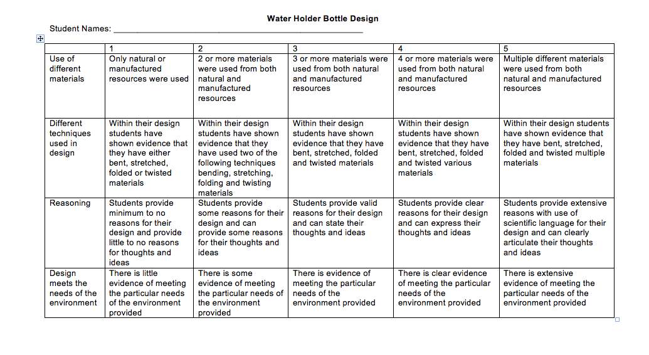

APPENDIX 2
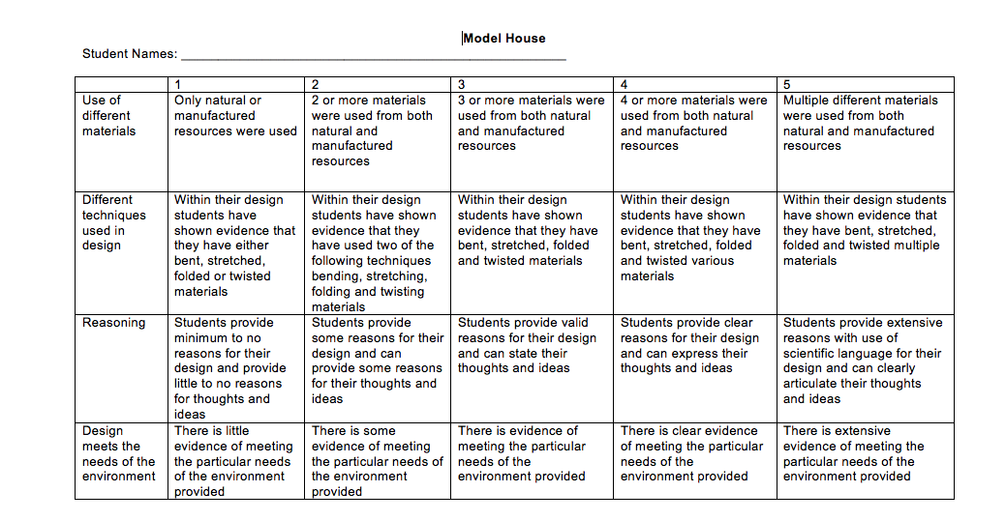
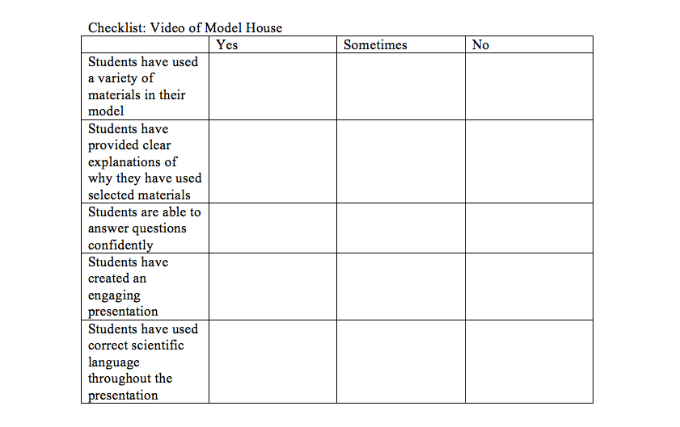
APPENDIX 3
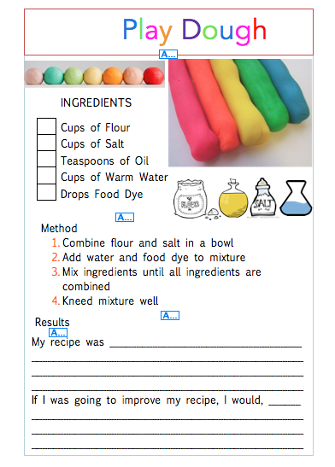
APPENDIX 4

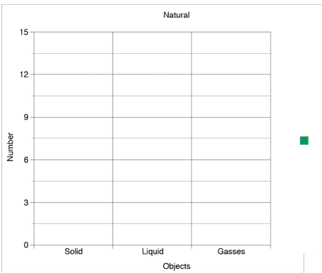
APPENDIX 5
Object | Man made or natural | Solid | Liquid | Gas
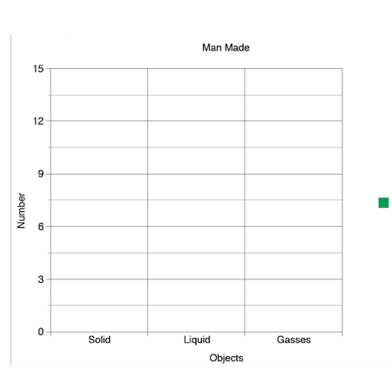

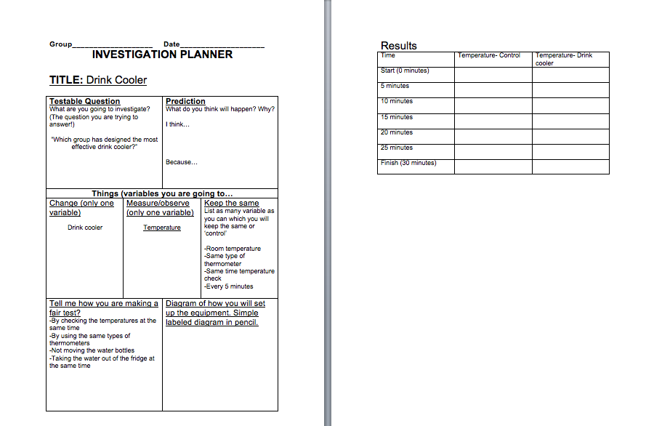
APPENDIX 6

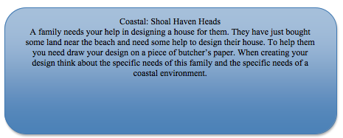
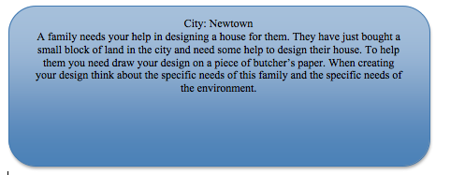
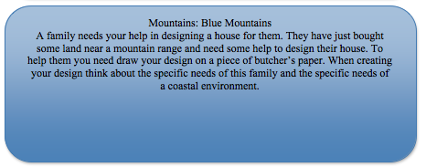
APPENDIX 7
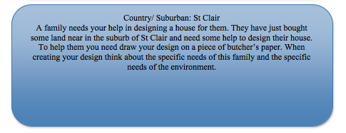
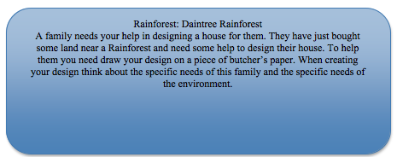
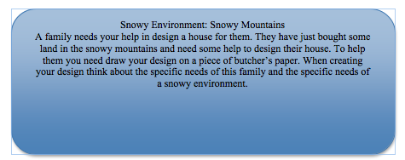
APPENDIX 7 CONTINUED

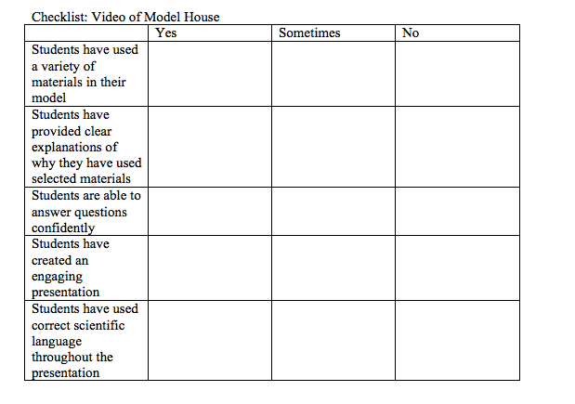
APPENDIX 8

APPENDIX 9
